Git hub

Open CMD

Type below codes in cmd

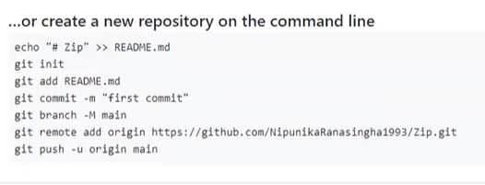put enter after all codes

Then go to git hub n see folder uploaded as below

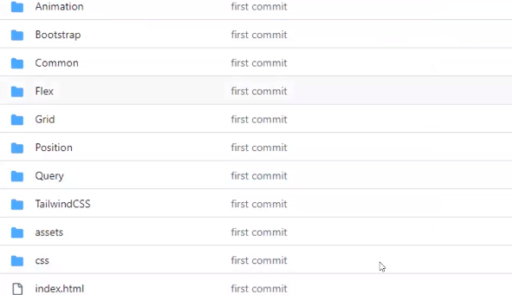

Update a file n upload to git

Go to main branch

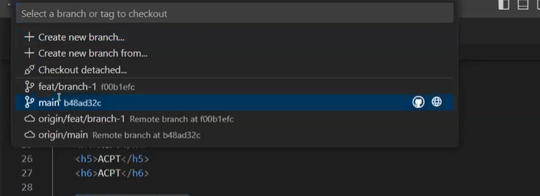

Create a branch

Feat/branch-01

Main branch eke copy ekak branch eka vidiyata hadala change eka karai